MC900412552[1]

March 2012

Dear Families,

As we enter the warm weather season, we need to address footwear. For safety reasons, in Kindergarten, we are requesting that your child wear appropriate footwear to school. Flip-flops, sandals without back straps, and platform shoes are okay for home use, but they are not encouraged for school.

If your child does wear sandals without backs, they will not be able to play on the playground equipment as it is not safe. Please have your child prepared with their sneakers each day or plan to leave an extra pair in their cubby. If you have any questions, please feel free to contact your child’s teacher.

MCj02521990000[1] Thank you for your cooperation.

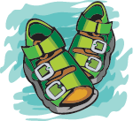 The Kindergarten Teachers